Fidelis Kaloki Mwanzia
BSCCS/2024/32530
Computer Science
BIT4133
Natural Language Processing with Deep Learning
Michael Nyoro
Year IV, Semester II
Project:
AI Chatbot
Technologies Used:
Python
Nltk
Jupyter Notebook

Github Repo Link:

Contents
WEEK 1: INTRODUCTION TO NLP AND APPLICATIONS 4
Packages Installation 4
Jupyter Notebook Setup. 4
Nltk Installation 5
Tokenisation output 5
Stop word removal. 6
NLP Applications. 6
WEEK 2: N-GRAM AND POS TAGGING 7
2.1 Language Modeling and Sentence Structure Analysis. 7
WEEK 3: Hidden Markov Models and Sequence Labelling. 10
3.1 Use of HMM Models. 10
3.1.1 Speech Recognition. 10
3.1.2 Chatbots. 10
WEEK 4: Synctactic and Semantic Analysis. 11
4.1 Installing spacy. 11
4.2 Dependency Parsing. 11
WEEK 5: CAT 1 PREPARATION AND MINI NLP PROJECTS 13
5.1 Complete NLP pipeline 13
5.2 Mini Chatbot simulation. 13

Figure 1:Python Installation 5
Figure 2: Jupyter Notebook Setup 5
Figure 3: NLTK Installation 6
Figure 4: Tokenization output 6
Figure 5: Stop word Removal 7
Figure 6: NLP Applications 7
Figure 7: Bigram output 8
Figure 8:POS Tagging code and output. 8
Figure 9: Language prediction code and output. 9
Figure 10:Sentence Analysis code and output. 10
Figure 11: spaCy installed 12
Figure 12: Code snippet showing POS 12
Figure 13: Complete NLP Pipeline 14
Figure 14:Chatbot sim 14

WEEK 1: INTRODUCTION TO NLP AND APPLICATIONS

Packages Installation
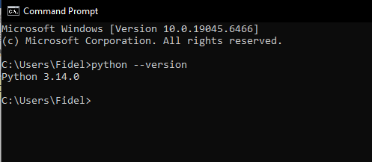
Figure 1:Python Installation

Jupyter Notebook Setup.
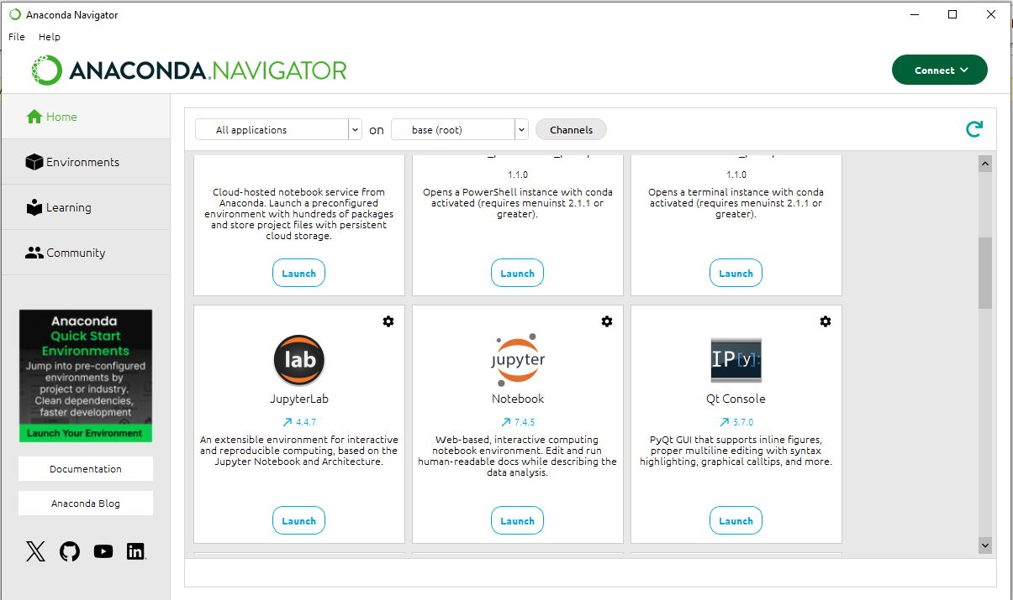
Figure 2: Jupyter Notebook Setup

Nltk Installation
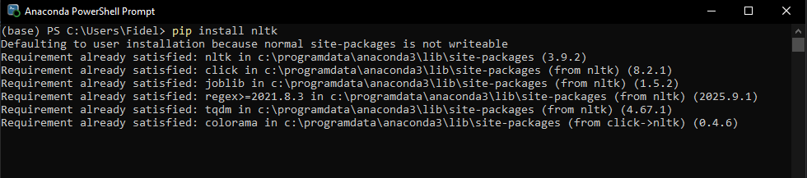
Figure 3: NLTK Installation

Tokenisation output
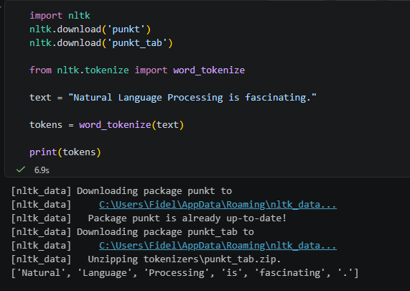
Figure 4: Tokenization output

Natural Language Processing (NLP) is a branch of Artificial Intelligence (AI) that enables computers to understand, process, analyze, and generate human language.

Stop word removal.
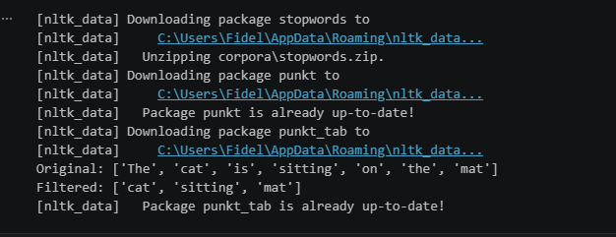
Figure 5: Stop word Removal

NLP Applications.
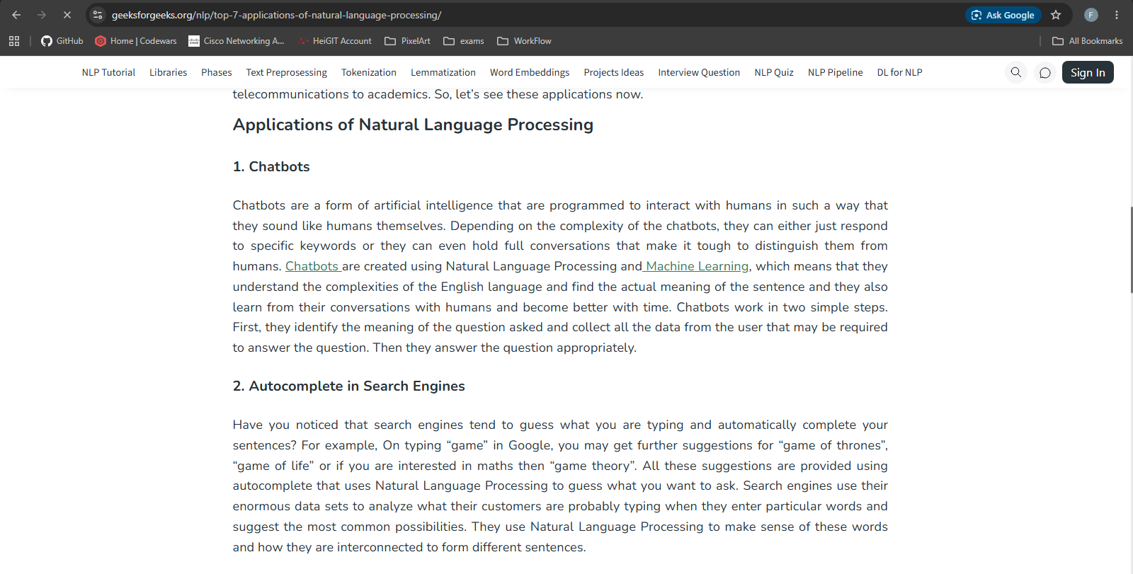
Figure 6: NLP Applications
Through the use of both stop word removal and tokenization, the main components of a sentence are extracted making it easier for a computer to learn far faster and more efficiently. Tokenisation breaks down the sentence and stop word removal removes the unnecessary parts.

WEEK 2: N-GRAM AND POS TAGGING

2.1 Language Modeling and Sentence Structure Analysis.
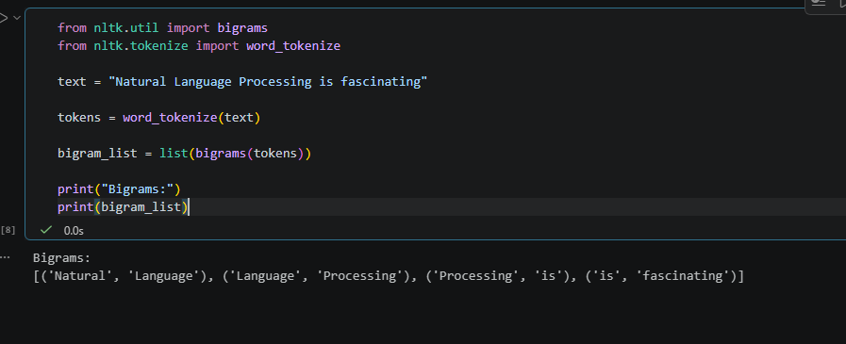
Figure 7: Bigram output
N grams are a sequence of n items, usually words that appear together in a text.
Bigrams are a pair of consecutive words while Trigrams are group of 3 consecutive words.
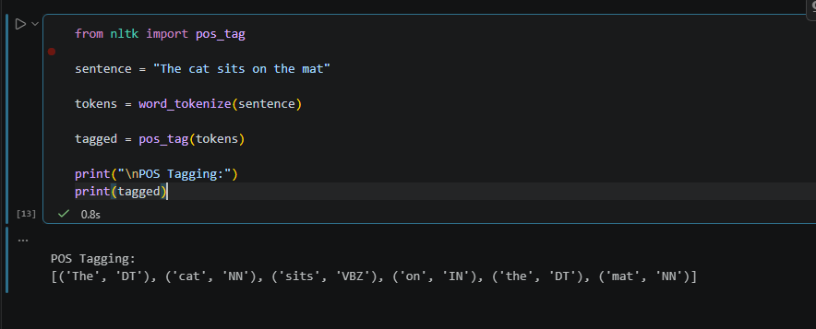
Figure 8:POS Tagging code and output.
Part of Speech tagging. An NLP technique whereby each word in a sentence is labelled according to it’s grammatical role.
Nouns, verbs, adjective, adverb, pronoun, preposition etc.
Computers don’t naturally understand grammar, POS tagging helps NLP systems understand sentence structure.
For Example, I read a book, Book a ticket.
Modern systems use rules, probabilities, machine learning and deep learning to determine the most likely tag based on context.

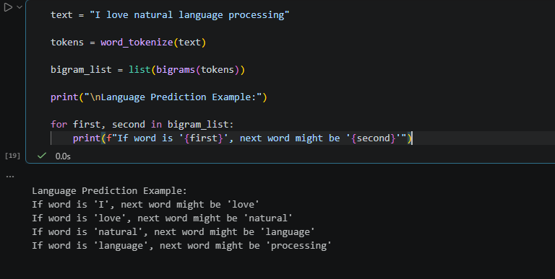
Figure 9: Language prediction code and output.
Entails predictive the next line of text based on previous lines.
For example, in a chatbot.
User: “Hello”
Chatbot: “Hi, how can I help you.”
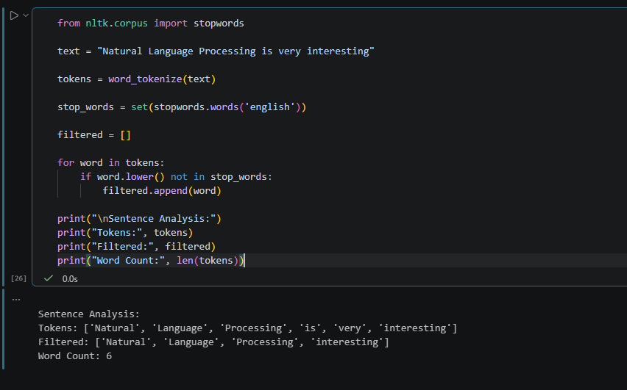
Figure 10:Sentence Analysis code and output.

Assignment 1:

Pos tagging.
Name entity recognition
Speech entity recognition
Simple python program on this.

WEEK 3: Hidden Markov Models and Sequence Labelling.

3.1 Use of HMM Models.
HMMS are statistical models used to represent systems where the actual states are hidden but can be inferred from observable outputs.

3.1.1 Speech Recognition.
Speech is divided into small sounds units called phonemes, that phoneme is actually hidden. What’s used is actually the acoustic signal.
HMMs estimate the most likely sequence of words from the observed sounds.
e.g speech “HI”, the observed audio waveform goes through HMM which predicts the phoneme that matches. Which is “HI”.

3.1.2 Chatbots.
HMMs model User intentions, Dialogue states, Conversation flow.
When a user says “I want to book a flight”, The hidden state is “Travel Booking Intent” gotten from the observed words: “book” and “flight”.
The Chatbot uses probabilities to infer the users intention and generate an appropriate response.

WEEK 4: Synctactic and Semantic Analysis.

4.1 Installing spacy.
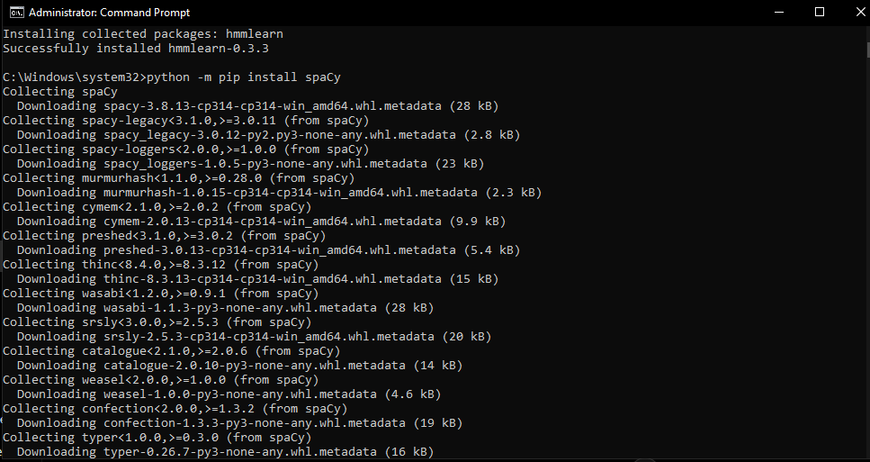
Figure 11: spaCy installed

4.2 Dependency Parsing.
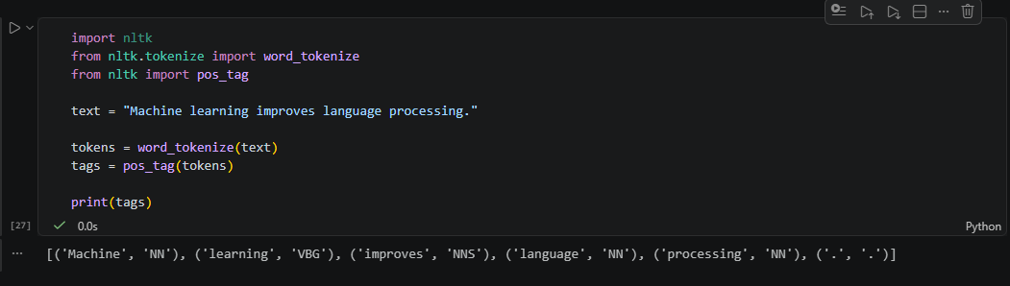
Figure 12: Code snippet showing POS
Subject is Machine learning,
Verb is Improves.
Object is Language processing.
Hence the sentence structure would be Machine learning -> improves ->Language processing.

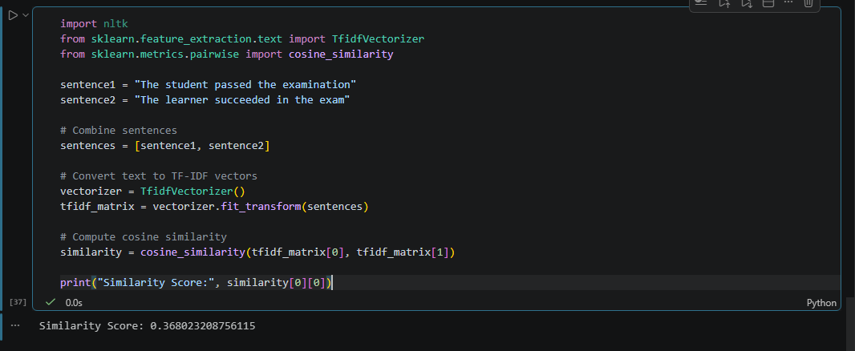
Used traditional TF-IDF because spaCy had issues.
The student passed the Examination.
The Learner succeeded in the exam.
Expected similarity score is high as bot sentences describe the same event:
Student = learner
Passed = succeeded
Examination =exam
The similarity score was low because traditional TF_IDF methods are limited in capturing semantic meaning compared to advanced models like spaCy.

WEEK 5: CAT 1 PREPARATION AND MINI NLP PROJECTS

5.1 Complete NLP pipeline
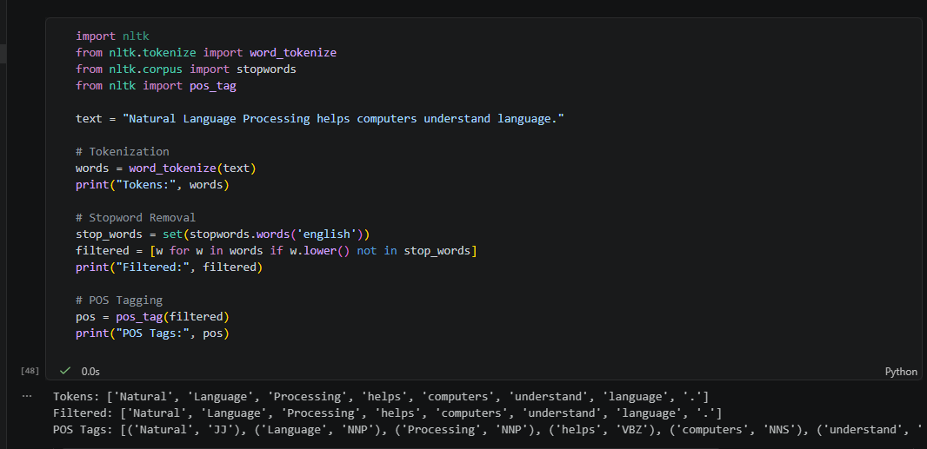
Figure 13: Complete NLP Pipeline

5.2 Mini Chatbot simulation.
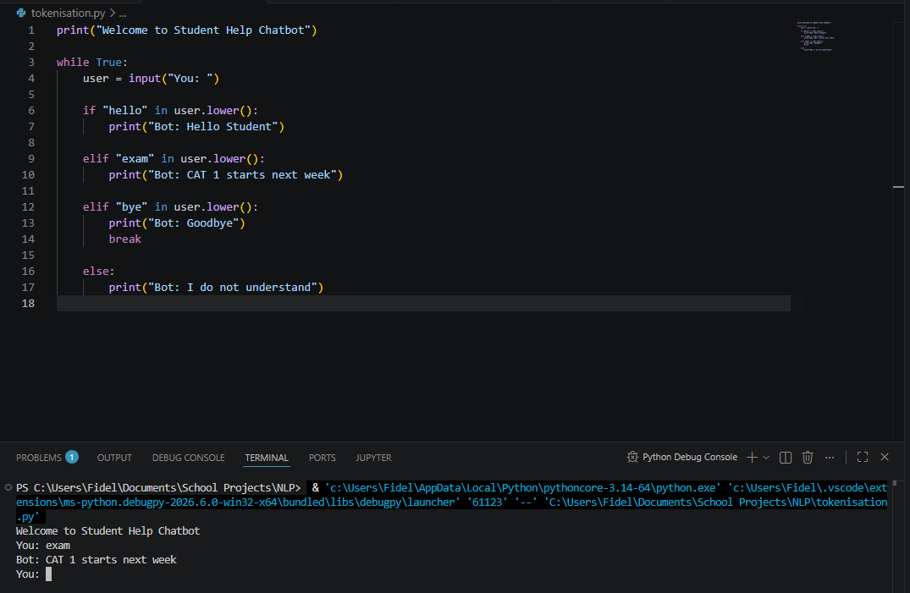
Figure 14:Chatbot sim

